**Vision for Industry®**

®

ht

In-Sig

**In-Sight® 1400**

**I/O Expansion Module**

**Installation and Reference Manual**

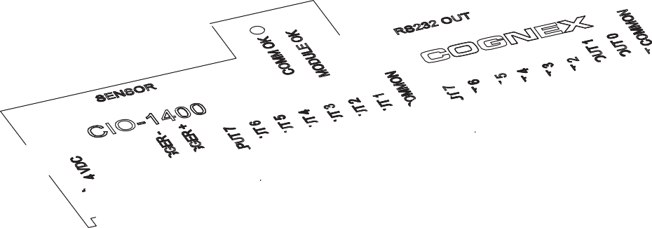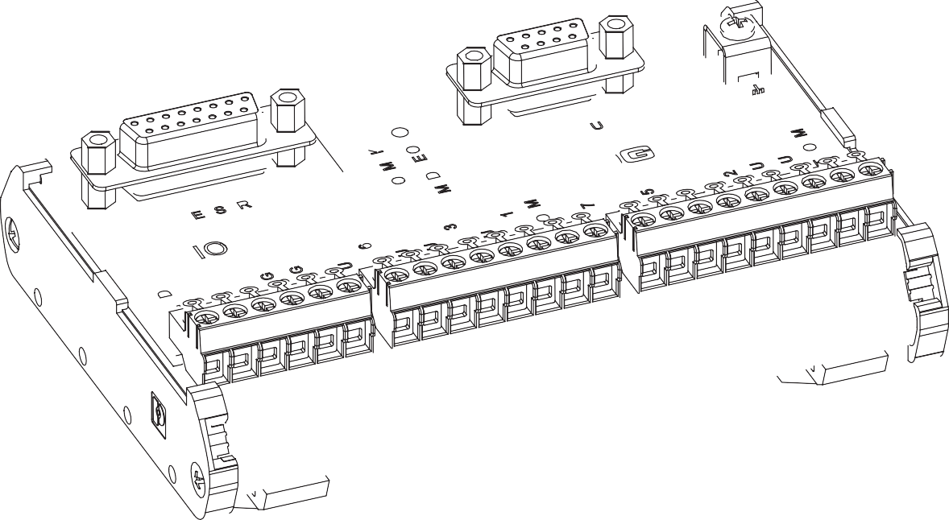

# Copyright, Trademarks, Patents

The software described in this document is furnished under license, and may be used or copied only in accordance with the terms of such license and with the inclusion of the copyright notice shown on this page. The software, this document, nor any copies thereof may be provided to or otherwise made available to anyone other than the licensee. Title to and ownership of this software remains with Cognex Corporation or its licensor. Cognex Corporation assumes no responsibility for the use or reliability of its software on equipment that is not supplied by Cognex Corporation. Cognex Corporation makes no warranties, either express or implied, regarding the described software, its merchantability or its fitness for any particular purpose.

The information in this document is subject to change without notice and should not be construed as a commitment by Cognex Corporation. Cognex Corporation is not responsible for any errors that may be present in either this document or the associated software.

This document may not be copied in whole or in part, nor transferred to any other media or language, without the written permission of Cognex Corporation.

Cognex P/N 597-0104-01

Copyright © 2007 Cognex Corporation. All Rights Reserved.

The hardware and portions of the software described in this document may be covered by one or more of the following U.S. patents (other U.S. and foreign patents are pending):

Hardware 4,972,359; 5,526,050; 5,657,403; 5,793,899

Vision Tools 5,495,537; 5,548,326; 5,583,954; 5,602,937; 5,640,200; 5,717,785;

5,742,037; 5,751,853; 5,768,443; 5,796,868; 5,818,443; 5,825,483;

5,825,913; 5,845,007; 5,859,466; 5,872,870; 5,909,504

The following are registered trademarks of Cognex Corporation: Cognex

Cognex, Vision for Industry In-Sight "crosshair" logo

In-Sight

The following are trademarks of Cognex Corporation: The Cognex logo

Other product and company names mentioned herein are the trademarks, or registered trademarks, of their respective owners.

# Regulations/Conformity

|  |  |
| --- | --- |
| **Declaration of Conformity** | |
| **Manufacturer**: | Cognex Corporation One Vision Drive Natick, MA 01760 USA |
| Declares this  -marked Machine Vision System Product | |
| **Product Number**: | In-Sight® 1400 I/O Expansion Module: P/N 800-9012-2R (RoHS compliant) |
| **Complies With**: | 89/336/EEC Electromagnetic Compatibility Directive |
| **Compliance Standards**: | EN 61000-6-4:2001 Class A EN 61000-3-2:2000 + A2:2005  EN 61000-3-3:1995 + A1:2001 + A2:2005 EN 61000-6-2:2005 |
| **European Representative**: | Cognex France Immeuble le Patio 104 avenue Albert 1er  92563 Rueil Malmaison France |
| **Safety and Regulatory** | |
|  | Certification marks are present on products.  CSA Class 2252.85 Process Control Equipment - Certified to U.S. Standards Equipment Class III, Pollution Degree 2. CSA22.1 EN 610101-1-04 |
| **FCC** | FCC Part 15, Class A  This device complies with Part 15 of the FCC Rules. Operation is subject to the following two conditions: (1) This device may not cause harmful interference, and  (2) this device must accept any interference received, including interference that may cause undesired operation.  This equipment generates, uses, and can radiate radio frequency energy and, if not installed and used in accordance with the instruction manual, may cause harmful interference to radio communications. Operation of this equipment in a residential area is likely to cause harmful interference in which case the user will be required to correct the interference at their own expense. |

**Precautions**

Observe these precautions when installing the In-Sight 1400 I/O Expansion Module to reduce the risk of injury or equipment damage:

* The 1400 I/O Expansion Module is intended to be supplied by a Listed, Direct

Plug-In Power Unit with a minimum output rated 24VDC, 750mA and marked Class 2, Limited Power Source (LPS). Any other voltage creates a risk of fire or shock and can damage the In-Sight components.

* Never connect the 1400 I/O Expansion Module to a power source other than 24VDC, and always use the 24VDC terminal block pins on the I/O module. Any other voltage creates a risk of fire or shock and can damage the hardware.
* Do not install the 1400 I/O Expansion Module in areas directly exposed to environmental hazards such as excessive heat, dust, moisture, humidity, impact, vibration, corrosive substances, flammable substances, or static electricity without a protective enclosure.
* To reduce the risk of damage or malfunction due to over-voltage, line noise, electrostatic discharge (ESD), power surges, or other irregularities in the power supply, route all cables and wires away from high-voltage power sources.
* The I/O Expansion Module does not contain user-serviceable parts. Do not make any electrical or mechanical modifications. Unauthorized modifications may violate your warranty.
* Changes or modifications not expressly approved by the party responsible for regulatory compliance could void the user’s authority to operate the equipment.
* The 1400 I/O Expansion Module is intended for indoor use only.

# Table of Contents

### Introduction

* 1. In-Sight Model 1400 I/O Expansion Module Overview 1
  2. In-Sight Support 2

1. Installation
   1. Connecting the 1400 I/O Expansion Module 3
   2. Configuring the Software 7
      1. Configuring an In-Sight Sensor to Recognize the I/O Module 7
      2. Configuring the 1400 I/O Expansion Module Serial Port Settings 10
2. Specifications
   1. General Specifications 13
   2. Input and Output Specifications 14
      1. General Purpose Inputs 14
      2. Trigger Input 15
      3. General Purpose Outputs 16
      4. High Speed Outputs 17
   3. Connector and Terminal Block Specifications 18
      1. RS-232 Serial Connector 18
      2. In-Sight Sensor Connector 19
      3. Terminal Block Assignments 20
   4. Dimensions 21

Appendix A

* 1. Configuring Discrete Outputs 23
     1. Line Name 24
     2. Line Type 24
     3. Line Details 25
  2. Configuring Discrete Inputs 25
     1. Line Name 26
     2. Line Type 27
     3. Signal Type 27

Appendix B

* 1. Configuring an In-Sight 3400 to Recognize the I/O Module 29
  2. Configuring the Expansion Module Serial Port Settings 32

Appendix C

* 1. Wiring Inputs and Outputs 33
     1. Trigger From PLC or Photo Eye - I/O Module Sources Current 34
     2. Trigger From PLC or Photo Eye - I/O Module Sinks Current 35
     3. Input From PLC - I/O Module Sources Current 36

Table of Contents

* + 1. Input From PLC - I/O Module Sinks Current 37
    2. Output to PLC - I/O Module Sources Current 38
    3. Output To PLC - I/O Module Sinks Current 39
    4. Output To Pilot Light or Relay - I/O Module Sources Current 40
    5. Output To Pilot Light or Relay - I/O Module Sinks Current 41
    6. High Speed Output To Strobe Controller - I/O Module Sinks Current 42

**List of Figures**

Figure 1-1: Model 1400 I/O Expansion Module (P/N 800-9012-2R) 1

Figure 1-2: I/O Cable 2

Figure 2-1: Connecting I/O Wires 4

Figure 2-2: Connecting the I/O Cable and Serial Cable 5

Figure 2-3: Connecting the Expansion Module to an In-Sight Sensor 6

Figure 2-4: Connecting Power (+24 VDC and Ground Wires) 7

Figure 2-5: Accessing the I/O Output Settings 8

Figure 2-6: Discrete Output Settings 9

Figure 2-7: Accessing the Serial Port Settings 10

Figure 2-8: Default Serial Port Settings 11

Figure 3-1: General Purpose Input 14

Figure 3-2: Trigger Input 15

Figure 3-3: General Purpose Output 16

Figure 3-4: High Speed Output To Strobe Controller - (Sink Only) 17

Figure 3-5: 1400 I/O Expansion Module Dimensions 21

Figure A-1: Discrete Output Default Settings 23

Figure A-2: Discrete Input Default Settings 26

Figure B-1: System Menu 29

Figure B-2: Settings Menu 30

Figure B-3: Discrete Output Dialog, Default Configuration 30

Figure B-4: Discrete Output Dialog, Expansion module Configuration 31

Figure B-5: Serial Port Dialog 32

Figure C-1: Trigger From PLC or Photo Eye - I/O Module Sources Current 34

Figure C-2: Trigger From PLC or Photo Eye - I/O Module Sinks Current 35

Figure C-3: Input From PLC - I/O Module Sources Current 36

Figure C-4: Input From PLC - I/O Module Sinks Current 37

Figure C-5: Output to PLC - I/O Module Sources Current 38

Figure C-6: Output to PLC - I/O Module Sinks Current 39

Figure C-7: Output to Pilot Light or Relay - I/O Module Sources Current 40

Figure C-8: Output to Pilot Light or Relay - I/O Module Sinks Current 41

Figure C-9: High Speed Output To Strobe Controller - (Sink Only) 42

# List of Tables

Table 2-1: Model 1400 I/O Expansion Module Connectors and Indicators 3

Table 3-1: 1400 I/O Expansion Module General Specifications 13

Table 3-2: General Purpose Input Specifications 14

Table 3-3: Trigger Input Specifications 15

Table 3-4: General Purpose Output Specifications 16

Table 3-5: Output Specifications 17

Table 3-6: RS-232 Serial Connector Pin Assignments 18

Table 3-7: In-Sight Sensor Connector Pin Assignments 19

Table 3-8: Terminal Block Pin Assignment 20

Table A-1: In-Sight Discrete Output Capability by Sensor Model 23

Table A-2: Discrete Output Line Types 24

Table A-3: In-Sight Discrete Input Capability 25

Table A-4: Discrete Input Line Types 27

**1**

**Introduction**

### In This Section

* 1. In-Sight Model 1400 I/O Expansion Module Overview 1
  2. In-Sight Support 2

## In-Sight Model 1400 I/O Expansion Module Overview

ht ®

The In-Sight® Model 1400 I/O Expansion Module provides a convenient way to access the power, serial, trigger and high-speed output connections of the In-Sight 3400 and 5000 series sensors. The expansion module also extends the capabilities of these sensors by adding discrete inputs/outputs and hardware handshaking for serial communications.

In-Sig

Other features of the model 1400 I/O Expansion Module include:

* + - Detachable terminal blocks
    - LED status indicators - MODULE OK, COMM OK (data transmission), and one for trigger and each input and output
    - DIN-Rail mountable

An I/O cable is needed to connect an In-Sight sensor to the 1400 I/O Expansion Module. The I/O cable has a DB15 connector on one end, and an M12 connector on the other. (See Figure 1-2 on page 2.) I/O cables must be purchased separately.

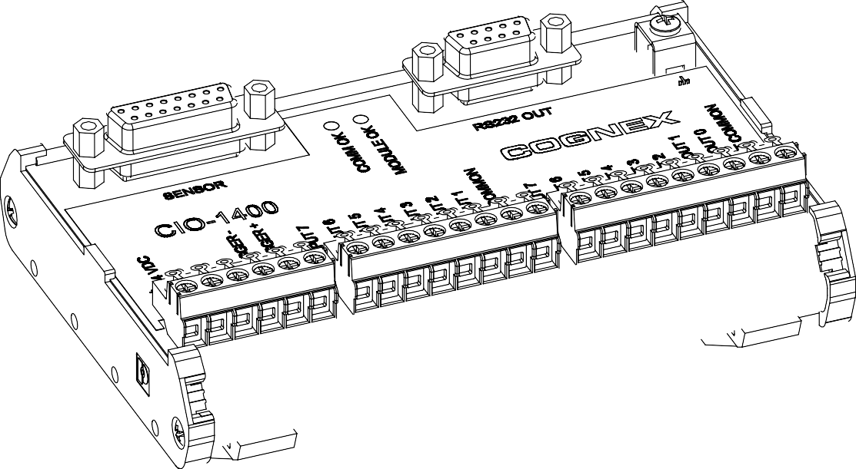

**Figure 1-1: Model 1400 I/O Expansion Module (P/N 800-9012-2R)**

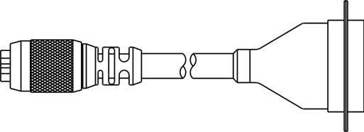

## In-Sight Support

**Figure 1-2: I/O Cable**

Many information resources are available to assist you in using the 1400 I/O Expansion Module with In-Sight vision sensors.

* + - *In-Sight® Explorer Help*, an online help file accessible from within the In-Sight Explorer software or on the In-Sight CD-ROM.
    - *Installing the In-Sight 3400 Vision Sensor*, Cognex P/N 597-0025-xx (English, French, Japanese and German versions available.)
    - *Installing In-Sight 5000 Series Vision Sensors*, Cognex P/N 597-0027-xx (English, Spanish, German, French, Japanese, Korean and Chinese (simplified) versions available.)
    - The In-Sight online support: [www.cognex.com/products/InSight/Support.asp](http://www.cognex.com/support/In-Sight.asp)

**2**

**Installation**

### In This Section

* 1. Connecting the 1400 I/O Expansion Module 3
  2. Configuring the Software 7

## Connecting the 1400 I/O Expansion Module

ht ®

This section explains how to connect the 1400 I/O Expansion Module using standard and optional components. For a complete list of options and accessories, contact your Cognex sales representative.

In-Sig

#### Table 2-1: Model 1400 I/O Expansion Module Connectors and Indicators

|  |  |
| --- | --- |
|  | |
| **Connector/Indicator** | **Description** |
| COMM OK LED | A yellow LED illuminates to indicate that the In-Sight sensor and I/O module are communicating properly. |
| MODULE OK LED | A yellow LED illuminates after the I/O module has powered on, initialized and is ready to communicate with the In-Sight sensor. |
| I/O and Trigger Status LEDs | A yellow LED illuminates to indicate that an input/output has switched ON. |
| SENSOR Connector | Connect an I/O module cable, which provides power, trigger and I/O signals to the connected In-Sight sensor. |
| RS232 OUT Connector | Connect a RS-232 serial cable, which provides the RS-232 communications between the I/O module and an external serial device. |
| Earth Ground Terminal | Connect a common earth ground. |
| Terminal Blocks | Connect 24VDC sensor power, trigger, external I/O, high-speed outputs and common connections. |

The 1400 I/O Expansion Module outputs labeled HS OUT 0 and HS OUT 1 correspond to the In-Sight 3400 and 5000 series sensor's built-in outputs. These signals are considered *high-speed* because they pass directly through the expansion module without processing or optical isolation with minimal delay.

**Note:**

To connect a 1400 I/O Expansion Module:

* + 1. Verify that any 24VDC power supplies are switched off.
    2. Determine which device will be connected to each input and output. Common wiring configurations are shown in Appendix C. Refer to section 3.3 on page 18 for connector and terminal block pin assignments.
    3. Use a screwdriver to loosen the appropriate screw terminals.
    4. Insert the signal and ground wire leads from remote I/O devices into the appropriate positions on the terminal block, as shown in Figure 2-1.
    5. Tighten the screw terminals with the screwdriver to secure the wire leads in the terminal block.

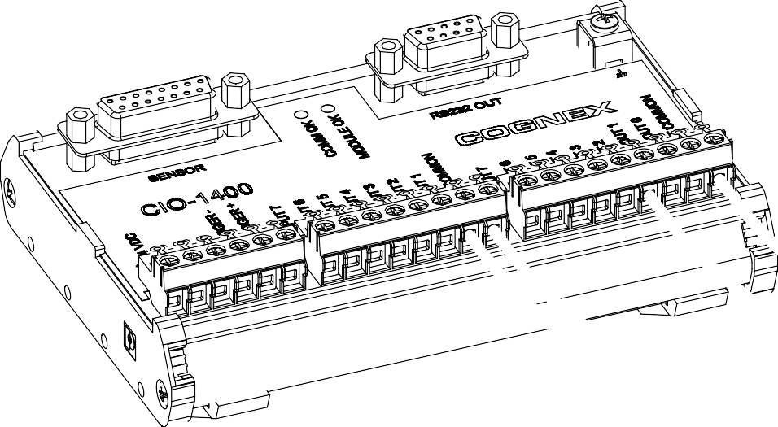

INPUT 1

IN COMMON

OUT 2

OUT COMMON

**Figure 2-1: Connecting I/O Wires**

* + 1. Plug the I/O module cable (DB15 connector) into the expansion module, as shown in Figure 2-2.
    2. If you want to connect the In-Sight sensor to a remote serial device, plug the RS-232 serial cable (DB9 connector) into the expansion module.

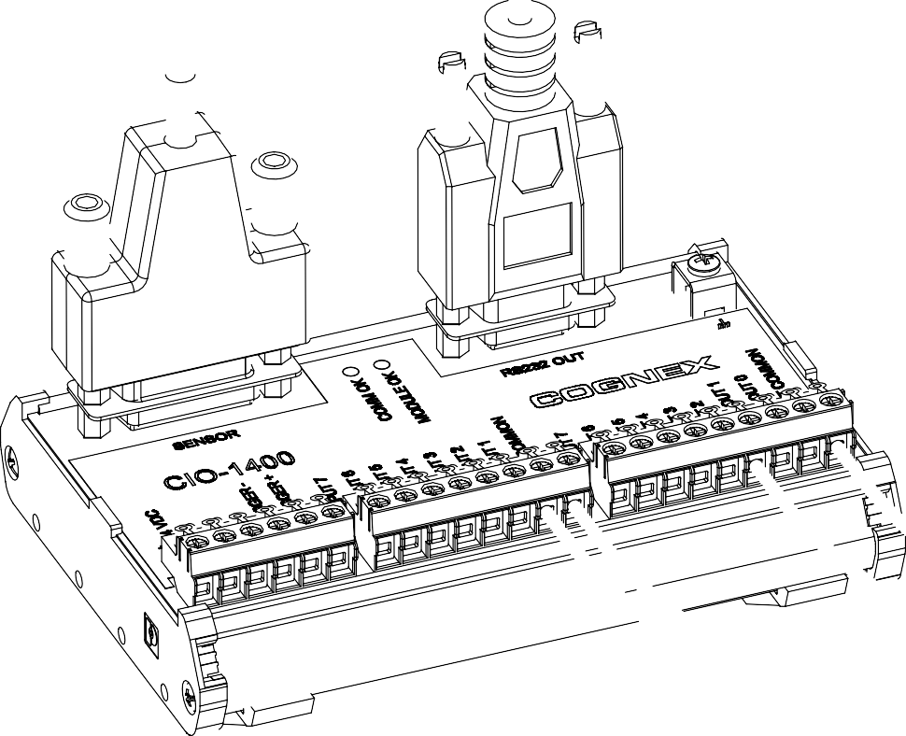

Serial Cable

I/O Cable

**Figure 2-2: Connecting the I/O Cable and Serial Cable**

* + 1. Connect the other end of the I/O Cable (keyed M12 connector) into the In-Sight sensor's breakout port (labeled 24VDC) as shown in Figure 2-3.

**24VDC**

**ENET**

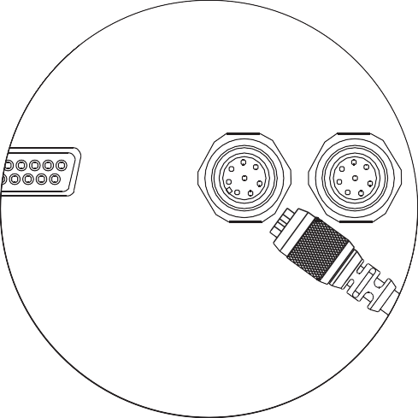

**CO**

**PWR ENET**

**TROL PAD**

**24VDC**

**ENET**

**CA**

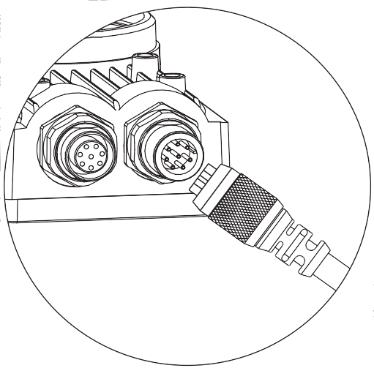**Figure 2-3: Connecting the Expansion Module to an In-Sight Sensor**

* + 1. Insert the +24VDC and negative ground wire leads from a 24VDC power supply into the two terminals (labeled +-24 VDC) on the Expansion Module (Figure 2-4).

**Caution:** Never connect the 1400 I/O Expansion Module to a power source other than 24VDC. Any other voltage creates a risk of fire or shock and can damage the hardware. Do not

connectors.

!

connect the 24VDC power source to any terminals other than the 24VDC + - power

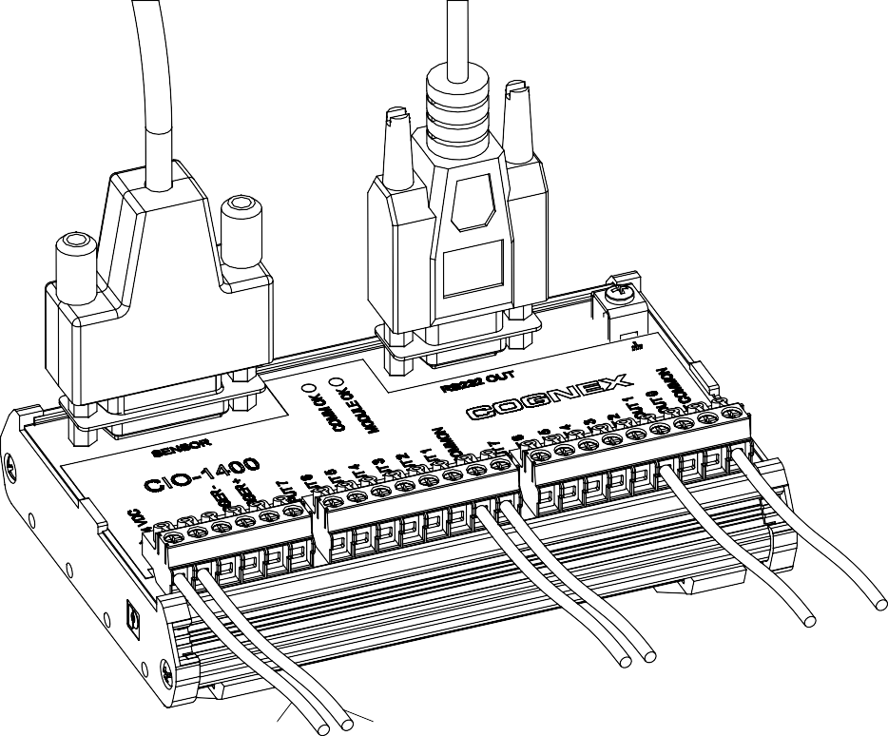

+24 VDC

-24 VDC

**Figure 2-4: Connecting Power (+24 VDC and Ground Wires)**

## Configuring the Software

Before the 1400 I/O Expansion Module can be used, the In-Sight sensor must be configured to recognize the availability of the additional inputs and outputs and the added RS-232 serial communication capability.

### Configuring an In-Sight Sensor to Recognize the I/O Module

The In-Sight sensor can be configured using In-Sight Explorer software or by an In-Sight 3400 directly. (See Appendix B.)

**Note:**

If the In-Sight sensor is using firmware version 3.4.0 or older, the firmware must first be upgraded to recognize and communicate with the 1400 I/O Expansion Module.

To configure the sensor using In-Sight Explorer:

* + - 1. Connect the 1400 I/O Expansion Module to your In-Sight sensor with an I/O cable as described in the previous section.
      2. Start the In-Sight Explorer software and log on to your sensor.
      3. From the Sensor menu, select Discrete I/O Settings, then Output Settings.

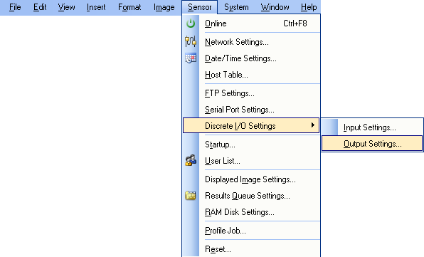

**Figure 2-5: Accessing the I/O Output Settings**

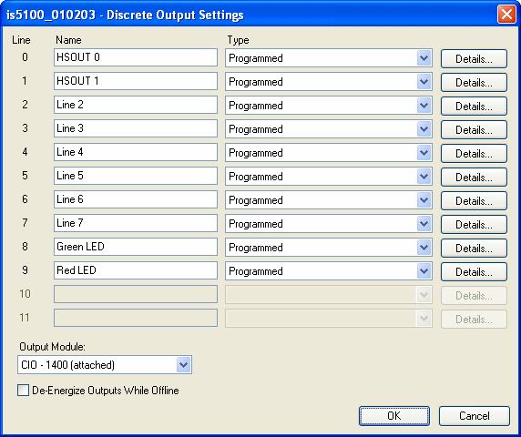

**Figure 2-6: Discrete Output Settings**

* + - 1. In the bottom left of the Discrete Output Settings dialog, select CIO-1400 from the Output Module list. The dialog will change to correspond to the available discrete outputs on the 1400 I/O Expansion Module.
      2. Configure the discrete output line settings (Line Name, Type and Details), and click OK to save the new settings to the sensor’s memory. See Appendix A for a basic overview of the Discrete I/O Settings. The *In-Sight® Explorer Help* file (F1) contains a more detailed explanation of these settings.
      3. Select OK to save the settings to the sensor’s memory.
         * The sensor can also be configured to recognize the 1400 I/O Expansion Module by selecting Discrete Input Settings from the Sensor menu and following steps 4 - 6.
         * When an In-Sight Explorer .JOB file containing a WriteDiscrete function is loaded on an In-Sight sensor to which the I/O Expansion Module has just been added, the Start Bit and Number of Bits parameters in WriteDiscrete must be changed to reflect the new configuration of the I/O lines.

**Notes:**

### Configuring the 1400 I/O Expansion Module Serial Port Settings

**Note:**

Before you configure serial port settings, the expansion module must be recognized by the sensor. (See section 2.2.1.)

To configure RS-232 serial port settings:

* + - 1. From the Sensor menu, select Serial Port Settings.

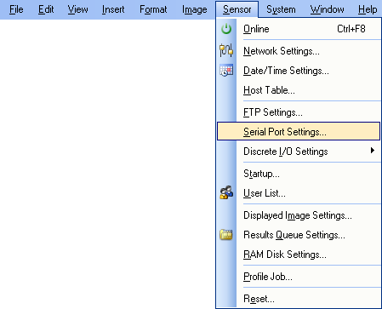

**Figure 2-7: Accessing the Serial Port Settings**

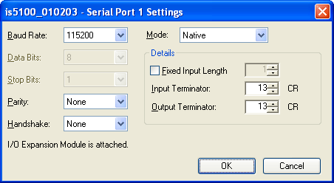

**Figure 2-8: Default Serial Port Settings**

* + - 1. Select the serial communication protocol of your device from the Mode list.
      2. Configure the serial port settings (Baud Rate, Parity, Handshake and Details) (if applicable), and click OK to save the new settings to the sensor’s memory.

See the *In-Sight® Explorer Help* file (F1) for a more detailed explanation of these settings.

**3**

**Specifications**

### In This Section

* 1. General Specifications 13
  2. Input and Output Specifications 14
  3. Connector and Terminal Block Specifications 18
  4. Dimensions 21

## General Specifications

#### Table 3-1: 1400 I/O Expansion Module General Specifications

ht ®

In-Sig

|  |  |  |
| --- | --- | --- |
| **Specification** | | **Description** |
| Compatibility | | In-Sight 3400 and In-Sight 5000 Series Vision Sensors |
| I/O | Trigger | 1 optically isolated trigger input |
| Inputs | 7 optically isolated discrete (general-purpose) |
| Outputs | 6 optically isolated discrete (general-purpose) (Maximum 30 VDC, 100 mA) |
| High Speed Outputs | 2 non-isolated discrete (high-speed) (Maximum 28 VDC, 200 mA) |
| Communications | Serial | 1 RS-232C port (2400 to 115,200 baud rates), 8 data bits,  1 stop bit, RxD, TxD and Flow Control (RTS/CTS & XOn/XOff) |
| Status LEDs | | MODULE OK, COMM OK, one for trigger and each input and output |
| Mechanical | Housing | Black plastic |
| Mounting | #3 DIN-rail (35 mm) |
| Dimensions | Width: 130.0 mm (5.12 in), Depth: 89.6 mm (3.53 in),  Height: 46.6 mm (1.84 in) |
| Terminal Block | 26 to 16 AWG  Torque 0.4 Nm (3.5 in-lb.) |
| Weight | 164 g (5.8 oz.) |
| Power Supply | | 24 VDC ±10%, 750 mA |
| Environmental | Temperature | Operating: 0°C to 50°C (0°F to 122°F) Storage: –10°C to 65°C (0°F to 149°F) |
| Humidity | Operating and Storage: 0 to 90%, non-condensing |
| Altitude | 2000 m (6565 ft) |
| Pollution Degree | 2 |
| Shock | 80 G per IEC 68-2-27 |
| Vibration | 10 G per IEC 68-2-6 |
| Regulatory Compliance | | CE, FCC, CSA, RoHS |

## Input and Output Specifications

### General Purpose Inputs

The 1400 I/O Expansion Module extends the capabilities of supported In-Sight vision sensors by providing seven independent, general-purpose inputs (INPUT 1 - INPUT 7) that can be used to trigger sensor events. General purpose inputs are optically isolated and are typically connected (directly or indirectly) to a sensor (such as a limit switch, pressure switch, or temperature switch). See Appendix C for common wiring configurations.

**Note:**

Since all inputs share a common ground (IN COMMON), all connected input devices must be either current sinking or current sourcing.

#### Table 3-2: General Purpose Input Specifications

|  |  |  |
| --- | --- | --- |
| **Specification** | | **Description** |
| Voltage | | ON 10 to 30V (24V nominal) |
| OFF 0 to 8V |
| Current | | ON >3mA |
| Delay | Module | 1 ms (maximum delay due to the I/O module) |
| Total | 1.4 ms (Time between an input state change and completion of serial transmission to an In-Sight Sensor.) |

,1387 1

,1 &20021

2XWSXW WR

,Q-6LJKW 6HQVRU



2SWR-LVRODWRU

0LFURFRQWUROOHU

1.4 Nȍ

470 ȍ

1.4 Nȍ

,/2 ([SDQVLRQ 0RGXOH

**Figure 3-1: General Purpose Input**

### Trigger Input

The 1400 I/O Expansion Module provides inputs for triggering a connected In-Sight sensor (TRIGGER +, TRIGGER-). When the expansion module is connected to a supported

In-Sight sensor, trigger input signals travel directly through the expansion module and are optically isolated in the sensor. Trigger inputs are typically connected (directly or indirectly) to a sensor (such as a photo-detector).

#### Table 3-3: Trigger Input Specifications

|  |  |
| --- | --- |
| **Specification** | **Description** |
| Voltage | ON 3 - 28V (when connected to an In-Sight sensor) |
| OFF 0 - 12V |
| Current | 6mA (when connected to an In-Sight sensor) |

TRIGGER +

TRIGGER -

Output to

In-Sight Sensor



Opto-isolator

4.7 Nȍ

2.2 Nȍ

4.7 Nȍ

I/O Expansion Module

InSight Sensor

**Figure 3-2: Trigger Input**

### General Purpose Outputs

The 1400 I/O Expansion Module extends the capabilities of supported In-Sight vision sensors by providing six independent, general-purpose outputs (OUT 2 - OUT 7) that can be used to trigger remote events. General purpose outputs are optically isolated and are typically connected (directly or indirectly) to a load (such as a relay, indicator light or motor). See Appendix C for common wiring configurations.

**Note:**

Since all general purpose outputs share a common ground (OUT COMMON), all connected output devices must be either current sinking or current sourcing.

#### Table 3-4: General Purpose Output Specifications

|  |  |  |
| --- | --- | --- |
| **Specification** | | **Description** |
| Voltage | | 30V (24V nominal) |
| Current | | 100 mA (max), auto-reset fuse protection |
| Delay | Module | 150 µs (maximum delay due to the I/O module) |
| Total | 1.25 ms (time between an input state change and completion of serial transmission to an In-Sight Sensor) |

,QSXW IURP

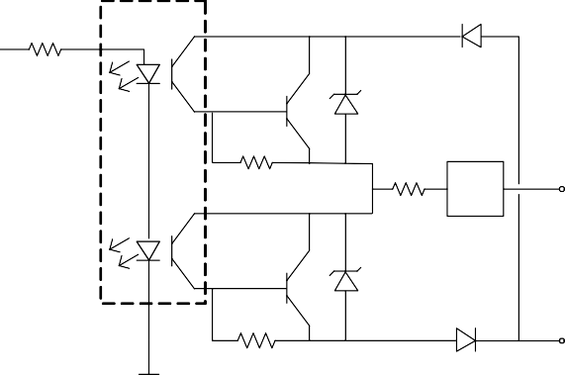

0LFURFRQWUROOHU

2SWR-LVRODWRUV

2.2 Nȍ

2.2 Nȍ

10 ȍ

37&

)XVH

2.2 Nȍ

,Q-6LJKW 6HQVRU

287 2

287 &20021

,/2 ([SDQVLRQ 0RGXOH

**Figure 3-3: General Purpose Output**

### High Speed Outputs

The 1400 I/O Expansion Module provides two high-speed discrete outputs (HS OUT 0, HS OUT 1) that can be used to trigger remote events. High-speed output signals travel through the I/O module without processing.

High speed outputs are not optically isolated and are typically connected (directly or indirectly) to a load (such as a relay, indicator light or a motor). Use the general purpose outputs if you want to isolate your output device.

* + - * High speed outputs can only be connected so that the 1400 I/O Module sinks current.
      * Do not connect a high speed output to OUT COMMON. You must use -24VDC as a return path. See Figure 3-4.

**Notes:**

#### Table 3-5: Output Specifications

|  |  |
| --- | --- |
| **Specification** | **Description** |
| Voltage | 28V (24V nominal) |
| Current | 200 mA (max) |

**High Speed Output - Wiring Example**

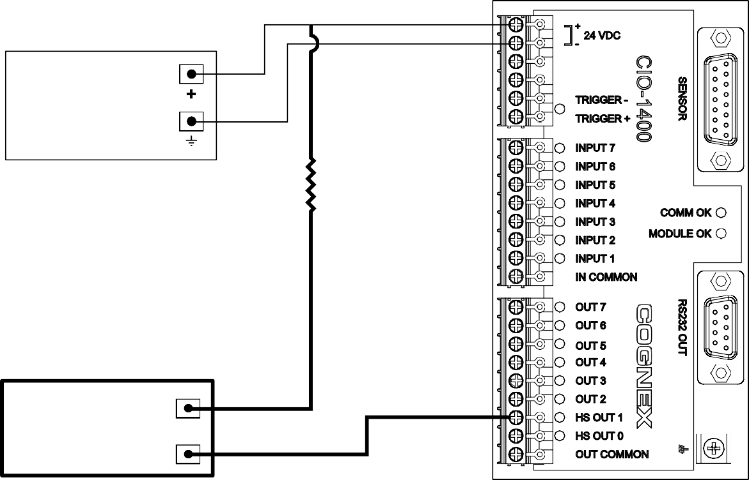

249 '& 32:(5 6833/< (IRU ,Q-6LJKW VHQVRU RQO\)

249+

249 &20021

5HVLVWRU PD\ EH UHTXLUHG WR UHGXFH YROWDJH WR PHHW VWUREH FRQWUROOHU HOHFWULFDO UHTXLUHPHQWV.

6752%( &21752//(5 (200P$ PD[)

**Figure 3-4: High Speed Output To Strobe Controller - (Sink Only)**

## Connector and Terminal Block Specifications

### RS-232 Serial Connector

The RS-232 serial connector connects a 1400 I/O Expansion Module and a remote serial device. Table 3-6 identifies the signal assignment for each pin on the connector.

#### Table 3-6: RS-232 Serial Connector Pin Assignments

|  |  |  |  |
| --- | --- | --- | --- |
|  | | | |
| **Pin #** | **Assignment** | **Pin #** | **Assignment** |
| 1 | No Connect | 6 | No Connect |
| 2 | TxD | 7 | CTS |
| 3 | RxD | 8 | RTS |
| 4 | No Connect | 9 | No Connect |
| 5 | GND |  |  |

### In-Sight Sensor Connector

The In-Sight sensor connector supplies power to the sensor and allows the sensor to transmit discrete I/O and serial data to and from the 1400 I/O Expansion Module. Table 3-7 shows the signal assignments for each pin on the connector.

#### Table 3-7: In-Sight Sensor Connector Pin Assignments

|  |  |  |  |
| --- | --- | --- | --- |
|  | | | |
| **Pin #** | **Assignment** | **Pin #** | **Assignment** |
| 1 | 24 VDC + | 9 | Not Used |
| 2 | TRIGGER + | 10 | Not Used |
| 3 | TRIGGER - | 11 | Not Used |
| 4 | HS OUT 0 | 12 | Not Used |
| 5 | HS OUT 1 | 13 | Not Used |
| 6 | TxD (sensor) | 14 | Not Used |
| 7 | RxD (sensor) | 15 | Not Used |
| 8 | 24VDC - |  |  |

### Terminal Block Assignments

Table 3-8 shows the signal assignments for each screw terminal on the expansion module's terminal blocks.

#### Table 3-8: Terminal Block Pin Assignment

|  |  |  |  |
| --- | --- | --- | --- |
| 1 23 | | | |
| **Pin #** | **Assignment** | **Pin #** | **Assignment** |
| 1 | + 24 VDC | 13 | INPUT 1 |
| 2 | - 24 VDC | 14 | IN COMMON |
| 3 | Not Used | 15 | OUT 7 |
| 4 | Not Used | 16 | OUT 6 |
| 5 | TRIGGER - | 17 | OUT 5 |
| 6 | TRIGGER + | 18 | OUT 4 |
| 7 | INPUT 7 | 19 | OUT 3 |
| 8 | INPUT 6 | 20 | OUT 2 |
| 9 | INPUT 5 | 21 | HS OUT 1 |
| 10 | INPUT 4 | 22 | HS OUT 0 |
| 11 | INPUT 3 | 23 | OUT COMMON |
| 12 | INPUT 2 |  |  |

## Dimensions

Dimensions are in millimeters [inches], are for reference only and may change without notice.



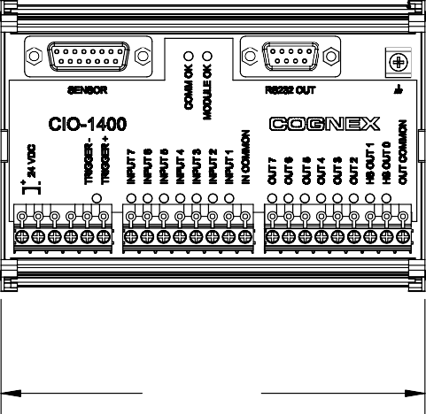

130.0 5.12

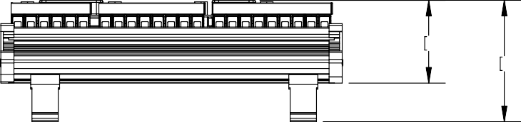

31.7 1.25

46.6 1.84

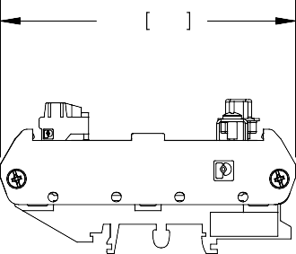

89.6 3.53

**Figure 3-5: 1400 I/O Expansion Module Dimensions**

ht

®

In-Sig

**Appendix A**

## Configuring Discrete Outputs

Configure the parallel digital output lines on an In-Sight sensor through the Discrete Output Settings dialog in In-Sight Explorer. Discrete output signals are written out from the In-Sight Explorer spreadsheet using the WriteDiscrete function. The number of outputs varies depending on the connected In-Sight sensor model.

#### Table A-1: In-Sight Discrete Output Capability by Sensor Model

|  |  |  |
| --- | --- | --- |
| **Model** | **Integrated Outputs (Sensor)** | **Additional Outputs (1400 I/O Module)** |
| In-Sight 3400 | Two (2) high-speed outputs | Six (6) general purpose outputs |
| In-Sight 5000 Series | Two (2) high-speed outputs Two (2) user-configurable LEDs (1 green, 1 red) | Six (6) general purpose outputs |

The Discrete Output default settings are shown in Figure A-1.



**Figure A-1: Discrete Output Default Settings**

#### Appendix A - Configuring Discrete Outputs

The Discrete Output Settings dialog shows three configurable line parameters: Name, Type and Details.

### Line Name

Assign a new name for an output line by selecting the default name and typing a new name. The name may be up to 15 characters. The Line Name is used for reference purposes only; it does not change the functionality of the output line and cannot be referenced in the spreadsheet.

### Line Type

Available Line Types are selected from the Type drop-down list.

#### Table A-2: Discrete Output Line Types

|  |  |
| --- | --- |
| **Type** | **Description** |
| Programmed | Enables a WriteDiscrete function in the spreadsheet to control the state of this output line. Either pulsed or steady-state. |
| High | Forces the output to HIGH (1). |
| Low | Forces the output to LOW (0). |
| Acquisition Start | Signals that the In-Sight sensor has initiated an acquisition. Always pulsed. |
| Acquisition End | Signals the completion of sensor acquisition. Always pulsed. |
| Job Completed | Signals each time the spreadsheet has completed an update. Always pulsed. |
| System Busy | HIGH when the In-Sight sensor is running a job or responding to user input, LOW when the In-Sight sensor is idle. |
| Job Load OK | Signals the successful loading of a job. Always pulsed. |
| Job Load Fail | Signals the failure of a job load. Always pulsed. |
| ERR: Missed Acquisition | Signals that an acquisition trigger was received before an Acquisition End signal was sent, or that no image buffer was available for image acquisition when an acquisition trigger was received. Always pulsed.  The Trigger parameter in the AcquireImage property sheet must be set to Camera to use the ERR: Missed Acquisition output. |
| ERR: Tracking Overrun | Signals that the spreadsheet issued a delayed discrete output signal sometime after the time it was expected. Always pulsed. |
| ERR: Tracking Queue Full | Signals that the spreadsheet issued a delayed discrete output for a line where a different output had been previously scheduled to occur at the same time. Always pulsed. |
| Online/Offline | HIGH when In-Sight is Online, LOW when In-Sight is Offline. |

**Table A-2: Discrete Output Line Types (Cont.)**

|  |  |
| --- | --- |
| **Type** | **Description** |
| Strobe | The rising or falling edge of the signal can be used to trigger a strobe. If the Strobe Trigger is set to Rising Edge, the signal is HIGH when the CCD is being exposed, otherwise the signal is LOW. If the Strobe Trigger is set to Falling Edge, the signal is LOW when the CCD is being exposed, otherwise the signal is HIGH. Always pulsed for the duration of the exposure. The exposure time must be 0.50 ms greater than the strobe pulse duration specified on the external strobe device.  The In-Sight sensor and strobe device must be connected to the same ground for the strobe to operate correctly.  In-Sight 3400 and 5000 series sensors allow the Strobe output type only on Line 1 (HSOUT 1) when Standard/CIO-1350 is selected and Line 1 (HSOUT 1) when CIO-1400 is selected. |

### Line Details

Click the Details button to access more I/O line settings. A dialog will appear with Pulse Length, Acquisition Delay and Strobe Trigger (Line 1, HSOUT 1 only) settings depending on the selected Line Type.

### Details Dialog Controls

* + - * **Pulse**: When this checkbox is enabled, the output will be pulsed. Disable this checkbox for a steady-state output. The output must be pulsed when the Acquisition Delay is greater than 0.
      * **Pulse Length**: Specifies the duration of an output pulse (10 to 1000 ms).
      * **Acquisition Delay**: Specifies the number of acquisition or tracking pulses

(0 to 1000) to delay the output after a signal pulse is received by an output Line. If Acquisition Delay = 0, then the In-Sight sensor updates the output line immediately on evaluating the WriteDiscrete function. If Acquisition Delay > 0, then the output Line is always pulsed.

* + - * **Strobe Trigger**: (Line 1 only) Rising Edge will trigger a strobe on the rising edge of the signal; Falling Edge will trigger a strobe on the falling edge of the signal.

## Configuring Discrete Inputs

The Discrete Input Settings dialog (Figure A-2) configures the parallel input lines on the active In-Sight sensor. Discrete input signals are read into the In-Sight spreadsheet using the ReadDiscrete function.

#### Table A-3: In-Sight Discrete Input Capability

|  |  |  |
| --- | --- | --- |
| **Model** | **Integrated Inputs (Sensor)** | **Additional Inputs (1400 I/O Module)** |
| In-Sight 3400 and 5000 series | Trigger  No general purpose inputs | Seven (7) general purpose inputs |

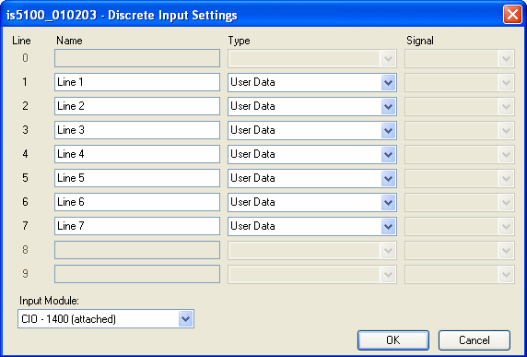

**Figure A-2: Discrete Input Default Settings**

The Discrete Input Settings dialog consists of three configurable parameters: Name, Type and Signal.

### Line Name

Assign a new name for an input line by selecting the default name and typing a new name. The name may be up to 15 characters. The Line Name is used for reference purposes only; it does not change the functionality of the input line and cannot be referenced in the spreadsheet.

### Line Type

Available Line Types are selected from the Type drop-down list.

#### Table A-4: Discrete Input Line Types

|  |  |
| --- | --- |
| **Type** | **Description** |
| User Data | General purpose input line; used to drive events in the spreadsheet or to set a value in the spreadsheet via the ReadDiscrete function. |
| Event Trigger | Triggers an event. To update the spreadsheet, the spreadsheet must contain an Event structure with its Trigger parameter set to this discrete input Line Number. |
| Job ID Number | Provides one bit of a Job ID Number, which is loaded when the State of a different input line with a Type of Job Load Switch is ON.  To use the Job ID Number function, the job to be loaded must be saved with a numerical prefix of 0 to 127. |
| Online/Offline | Forces the In-Sight sensor Offline or Online. 0 = Offline and 1 = Online.  When the Type is set to Online, the sensor may still be Offline if it has been set Offline manually in the In-Sight Explorer user interface or a Native Mode Set Online command, SO0, has been issued telling the In-Sight sensor to go Offline.  This input type may not be used on more than one input Line simultaneously. |
| Job Load Switch | ON reads all of the Job ID Number lines and loads the specified job.  This input type may not be used on more than one input Line simultaneously. |

### Signal Type

Select a signal type for the selected input line, which controls the sensitivity of the input line to edge transitions.

* + - * **Rising Edge**: Changes the State of the input line on the leading edge of a pulse.
      * **Falling Edge**: Changes the State of the input line on the falling edge of a pulse.
      * **Both Edges**: Changes the State of the input line on the leading edge and falling edge of a pulse. This option is only available when Event Trigger is the selected Type.

**Note:**

Signal Type is only available for Event Trigger and Job Load Switch line types.

ht

®

In-Sig

**Appendix B**

## Configuring an In-Sight 3400 to Recognize the I/O Module

Before the 1400 I/O Expansion Module can be used, the In-Sight 3400 sensor must be configured to recognize the availability of the additional inputs and outputs and the added RS-232 serial communication capability.

An In-Sight 3400 sensor can also be configured using In-Sight Explorer (see section 2.2.1).

**Note:**

If the In-Sight sensor is using firmware version 3.4.0 or older, the firmware must first be upgraded to recognize and communicate with the 1400 I/O Expansion Module.

To configure an In-Sight 3400 sensor directly:

* + 1. Connect the 1400 I/O Expansion Module to the In-Sight 3400, as described in section 2.1.
    2. Log on to the In-Sight 3400.
    3. Open the System menu (Figure B-1) and select Settings (Figure B-2).

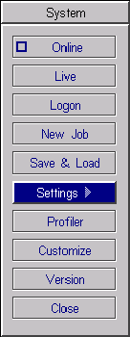

**Figure B-1: System Menu**

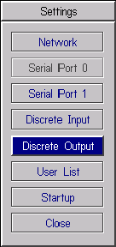

**Figure B-2: Settings Menu**

* + 1. From the Settings menu, select Discrete Output.

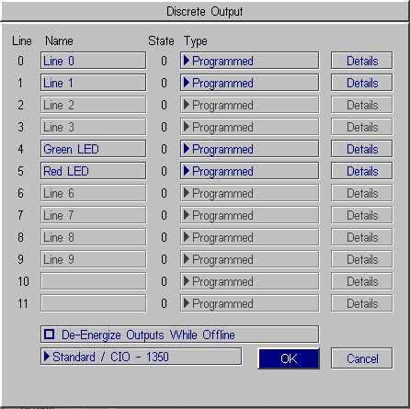

**Figure B-3: Discrete Output Dialog, Default Configuration**

##### *In-Sight® 1400 I/O Expansion Module Installation and Reference Manual*

* + 1. Open the drop-down list to the left of the OK button and select CIO - 1400. The Discrete Output dialog will automatically reconfigure to correspond to the 1400 I/O Expansion Module, as shown in Figure B-4.

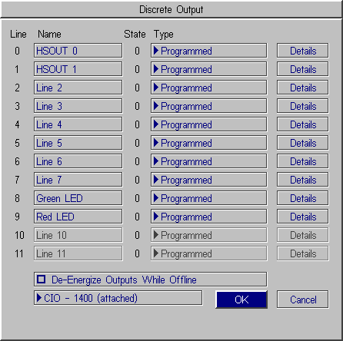

**Figure B-4: Discrete Output Dialog, Expansion module Configuration**

* + 1. Configure the discrete output line settings - Line Name, Type and Details (see Appendix A) and click OK to save the new settings to the sensor’s memory. See Appendix A for a basic overview of the Discrete I/O Settings. The *In-Sight® Explorer Help* file contains a more detailed explanation of these settings.
    2. Select OK to save the new settings to the sensor's memory.
       - The sensor can also be configured to recognize the 1400 I/O Expansion Module by selecting Discrete Input Settings from the Sensor menu and following steps 4 - 6.
       - When a .JOB file containing a WriteDiscrete function is loaded on an In-Sight sensor to which the I/O Expansion Module has just been added, the Start Bit and Number of Bits parameters in WriteDiscrete must be changed to reflect the new configuration of the I/O lines.

**Notes:**

**Appendix B - Configuring the Expansion Module Serial Port Settings**

**Note:**

## Configuring the Expansion Module Serial Port Settings

Before you configure serial port settings, the expansion module must be recognized by the sensor. (See section B.1.)

To configure RS-232 serial port settings:

* + 1. Open the System menu.
    2. Select Settings to open the Settings menu.
    3. Select Serial Port 1 (Figure B-5).

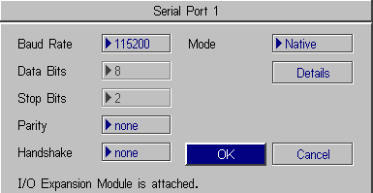

**Figure B-5: Serial Port Dialog**

* + 1. Select the serial communication protocol of your device from the Mode list.
    2. Configure the serial port settings (Baud Rate, Parity, Handshake and Details) (if applicable), and click OK to save the new settings to the sensor’s memory.

Refer to the *In-Sight® Explorer Help* file for details on using the Discrete Input/Output and Serial functions in the In-Sight 3400 user interface.

ht

®

In-Sig

**Appendix C**

## C.1 Wiring Inputs and Outputs

The following figures show basic wiring for some of the more common configurations.

* A connection to both the ground pin labeled - 24VDC, and the power pin labeled + 24 VDC are required to supply the In-Sight sensor with power.
* OUT COMMON is only for General Purpose Outputs (not High Speed Outputs).
* High Speed Outputs must be powered by connecting to the pin labeled +24VDC or by a separate power supply that is grounded to the pin labeled -24VDC.
* Unless necessary, power to your device(s) should not be provided from the I/O module terminal block pin labeled +24V. If power is provided from these pins, General Purpose Inputs and Outputs will no longer be optically isolated. Use a separate power supply to ensure that inputs/outputs are optically isolated.
* All General Purpose Inputs share a common connection (IN COMMON). All General Purpose Outputs share a separate common connection (OUT COMMON). Therefore, all input devices must be current sinking OR sourcing, and all output devices must be sinking OR sourcing.
* Do not connect a relay to an input configured as a Job Load Switch. A signal from a relay fluctuates enough (from contact bounce) that multiple job loads will be recognized.
* High Speed Outputs are not optically isolated, and can only be connected so that the 1400 I/O Module sinks current.

**Notes:**

### Trigger From PLC or Photo Eye - I/O Module Sources Current

The In-Sight sensor trigger input is energized by a 24VDC Common signal from a PLC or a photo eye.

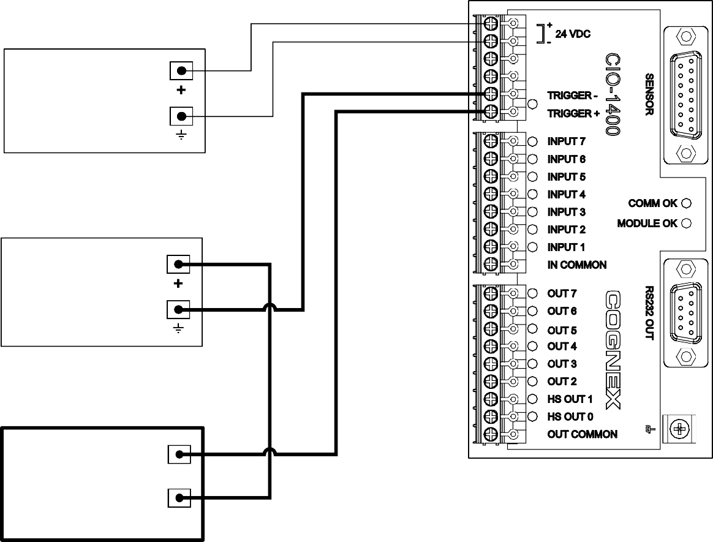

249 '& 32:(5 6833/< (IRU ,Q-6LJKW VHQVRU RQO\)

249+

249 &20021

249 '& 32:(5 6833/< (IRU 3/& RQO\)

249+

249 &20021

3+272 (<( RU 3/&

287387

249+ ('&)

**Figure C-1: Trigger From PLC or Photo Eye - I/O Module Sources Current**

### Trigger From PLC or Photo Eye - I/O Module Sinks Current

The In-Sight sensor trigger input is energized by a +24VDC signal from a PLC or a photo eye.

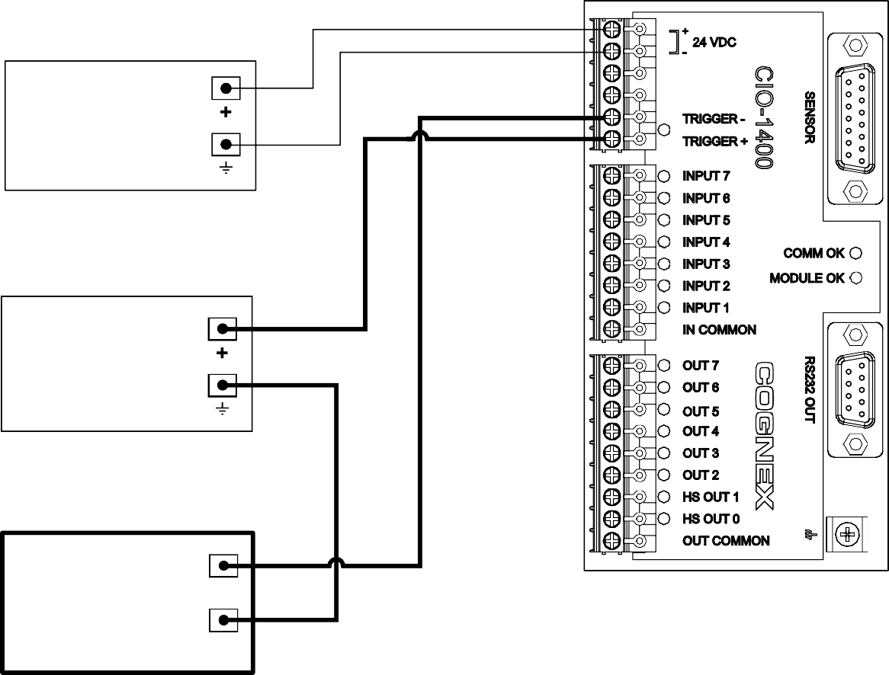

249 '& 32:(5 6833/< (IRU ,Q-6LJKW VHQVRU RQO\)

249+

249 &20021

249 '& 32:(5 6833/< (IRU 3/& RQO\)

249+

249 &20021

3+272 (<( RU 3/&

287387

249 &20021 ('&)

**Figure C-2: Trigger From PLC or Photo Eye - I/O Module Sinks Current**

### Input From PLC - I/O Module Sources Current

The In-Sight sensor input is energized by a +24VDC signal from a PLC.

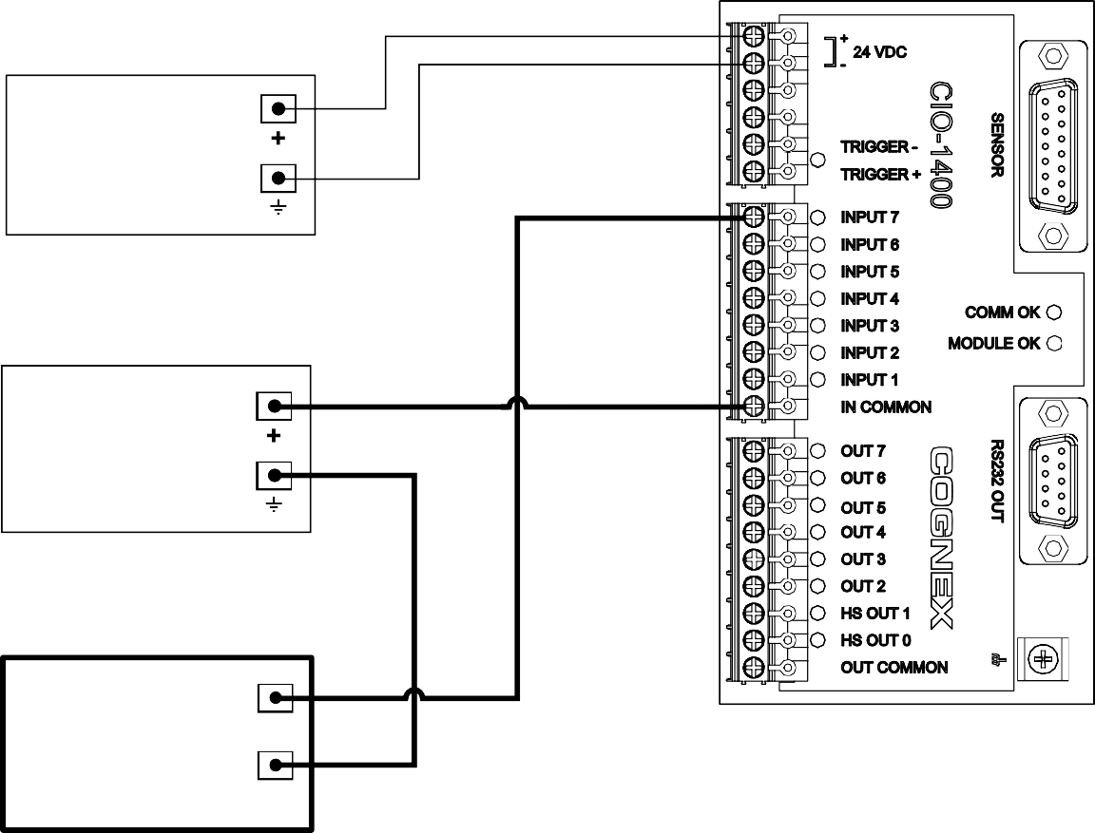

249 '& 32:(5 6833/< (IRU ,Q-6LJKW VHQVRU RQO\)

249+

249 &20021

249 '& 32:(5 6833/< (IRU 3/& RQO\)

249+

249 &20021

3/&

287387

249 &20021 ('&)

**Figure C-3: Input From PLC - I/O Module Sources Current**

### Input From PLC - I/O Module Sinks Current

The In-Sight sensor input is energized by a 24VDC Common signal from a PLC.

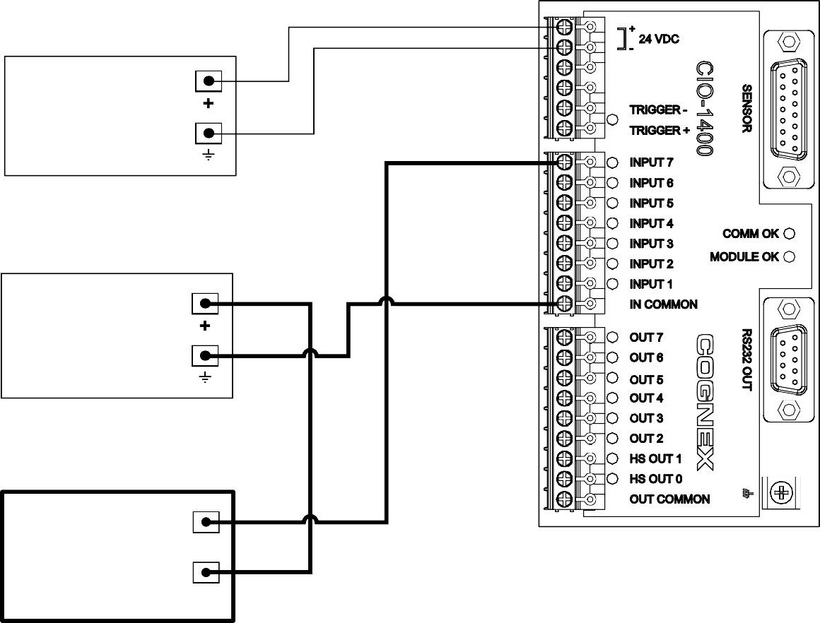

249 '& 32:(5 6833/< (IRU ,Q-6LJKW VHQVRU RQO\)

249+

249 &20021

249 '& 32:(5 6833/< (IRU 3/& RQO\)

249+

249 &20021

3/&

287387

249+ ('&)

**Figure C-4: Input From PLC - I/O Module Sinks Current**

### Output to PLC - I/O Module Sources Current

The PLC input is energized by a +24VDC signal from an In-Sight sensor.

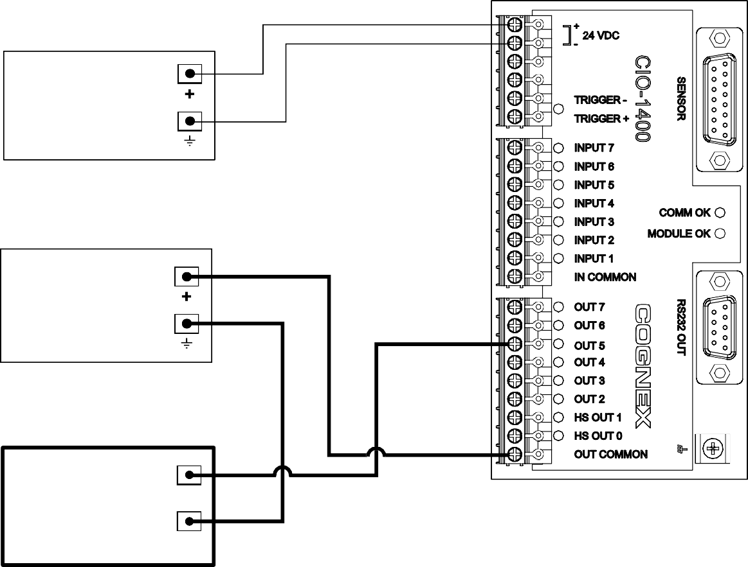

249 '& 32:(5 6833/< (IRU ,Q-6LJKW VHQVRU RQO\)

249+

249 &20021

249 '& 32:(5 6833/< (IRU 3/& RQO\)

249+

249 &20021

3/&

,1387

249 &20021 ('&)

**Figure C-5: Output to PLC - I/O Module Sources Current**

### Output To PLC - I/O Module Sinks Current

The PLC input is energized by a 24VDC Common signal from an In-Sight sensor.

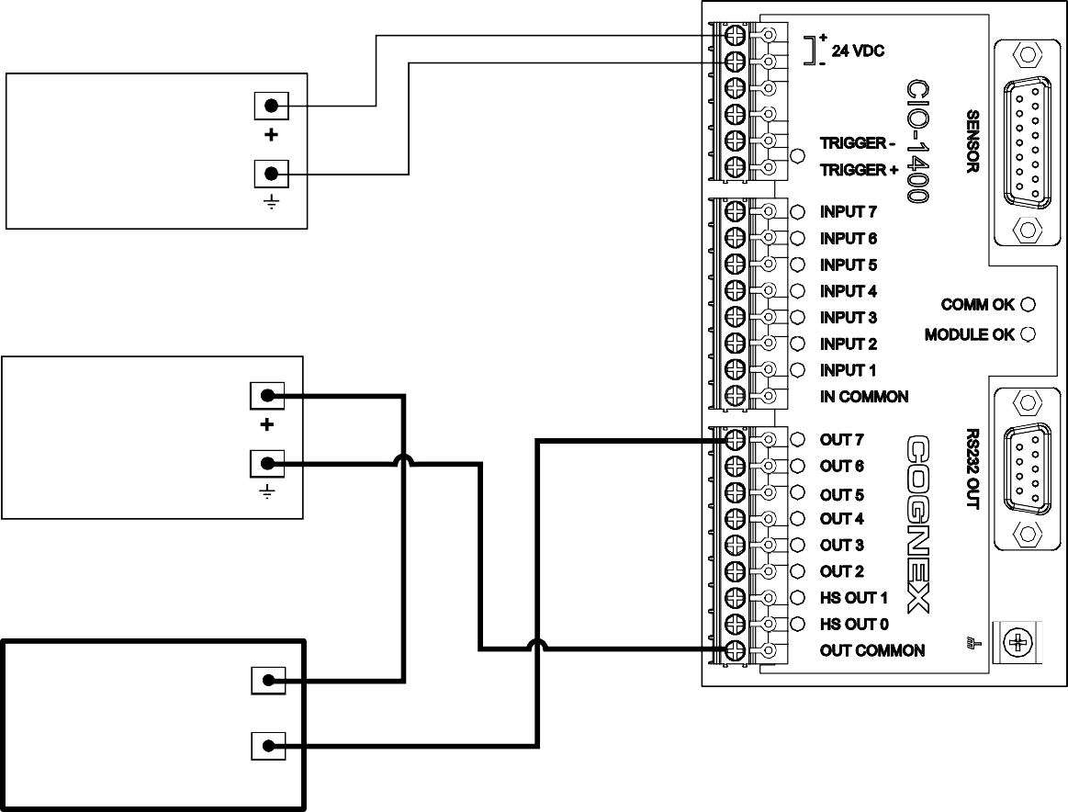

249 '& 32:(5 6833/< (IRU ,Q-6LJKW VHQVRU RQO\)

249+

249 &20021

249 '& 32:(5 6833/< (IRU 3/& RQO\)

249+

249 &20021

3/&

249+ ('&)

,1387

**Figure C-6: Output to PLC - I/O Module Sinks Current**

### Output To Pilot Light or Relay - I/O Module Sources Current

The pilot light or relay is energized by a + 24VDC signal from an In-Sight sensor.

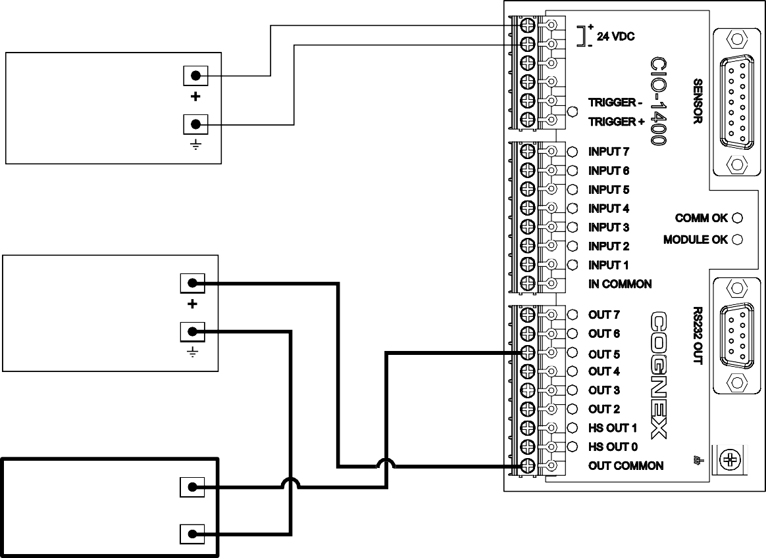

249 '& 32:(5 6833/< (IRU ,Q-6LJKW VHQVRU RQO\)

249+

249 &20021

249 '& 32:(5 6833/< (IRU 3/& RQO\)

249+

249 &20021

3,/27 /,*+7 RU 5(/$< (100P$ PD[)

**Figure C-7: Output to Pilot Light or Relay - I/O Module Sources Current**

### Output To Pilot Light or Relay - I/O Module Sinks Current

The pilot light or relay is energized by a 24VDC Common signal from an In-Sight sensor.

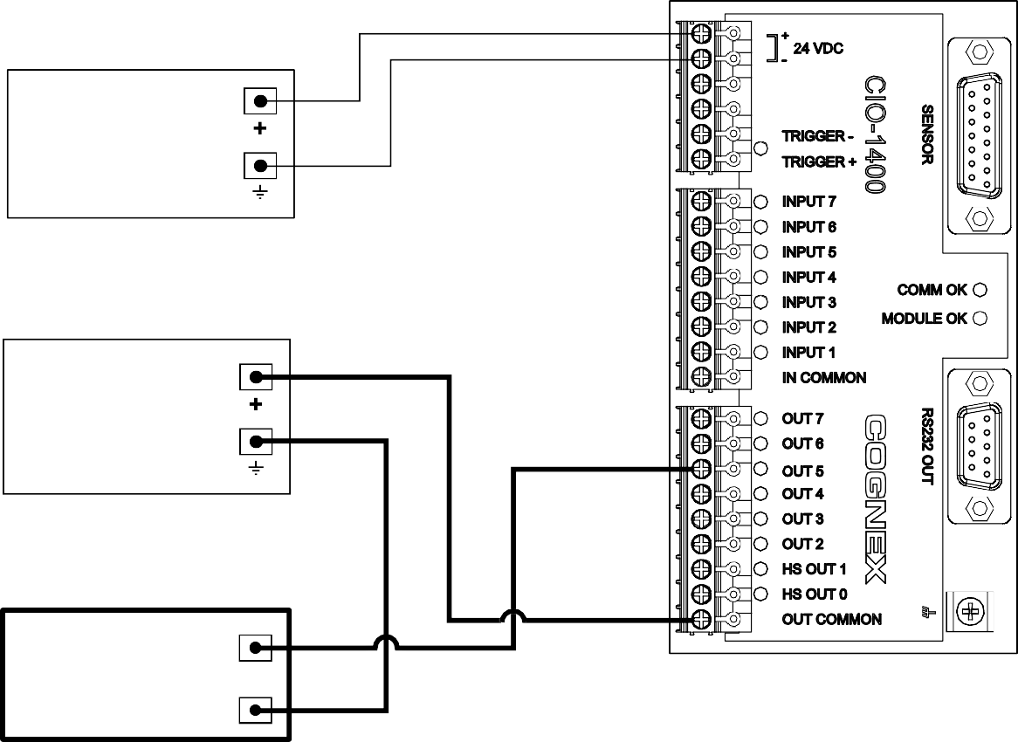

249 '& 32:(5 6833/< (IRU ,Q-6LJKW VHQVRU RQO\)

249+

249 &20021

249 '& 32:(5 6833/< (IRU 3/& RQO\)

249+

249 &20021

3,/27 /,*+7 RU 5(/$< (100P$ PD[)

**Figure C-8: Output to Pilot Light or Relay - I/O Module Sinks Current**

### High Speed Output To Strobe Controller - I/O Module Sinks Current

**Note:**

The I/O module can only sink current from a device connected to a High Speed Output; it cannot source current.

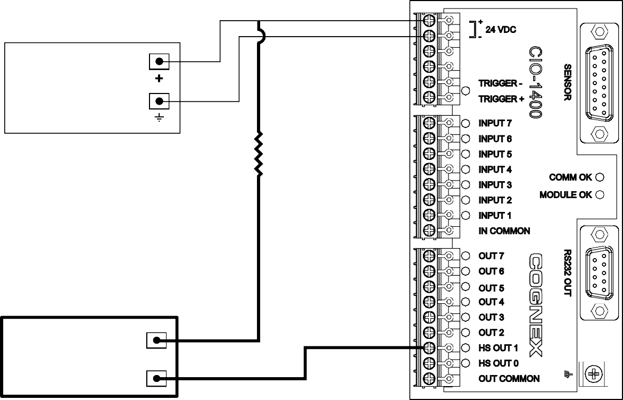

249 '& 32:(5 6833/< (IRU ,Q-6LJKW VHQVRU RQO\)

249+

249 &20021

5HVLVWRU PD\ EH UHTXLUHG WR UHGXFH YROWDJH WR PHHW VWUREH FRQWUROOHU HOHFWULFDO UHTXLUHPHQWV.

6752%( &21752//(5 (200P$ PD[)

**Figure C-9: High Speed Output To Strobe Controller - (Sink Only)**



In-Sight® 1400 I/O Expansion Module Installation and Reference Manual



**P/N 597-0104-01**

[**www.cognex.com**](http://www.cognex.com/)